Predicted cardiovascular risk for US adults with diabetes, chronic kidney disease, and ≥65 years of age

Byron C. Jaeger, PhD1, Swati Sakhuja, MPH2, Shakia T. Hardy, PhD, MPH2, Oluwasegun P. Akinyelure, MD, MPH2, Joshua D. Bundy, PhD, MPH3, Paul Muntner, PhD2, and Paul K. Whelton, MD, MSc3

1. Department of Biostatistics, University of Alabama at Birmingham
2. Department of Epidemiology, University of Alabama at Birmingham
3. Department of Epidemiology, Tulane University

**Short title**: Cardiovascular risk for US adults

**Address for correspondence:**

Byron C. Jaeger University of Alabama at Birmingham 327M Ryals Public Health Building 1665 University Blvd Birmingham, Alabama 35294-0022

**Word count (including references, but not tables and legends)**: 3837

**number of tables**: 4 (3 main tables; 1 supplemental table)

**number of figures**: 5 (2 main figures, 3, supplemental figues)

**number of supplementary digital content files**: 0

**Sources of Funding:**

Drs Muntner and Jaeger receive support through grant R01HL144773 from the National Heart, Lung, and Blood Institute and grant 15SFRN2390002 from the American Heart Association.

Dr. Hardy receives support through R01HL139716 from the National Heart, Lung, and Blood Institute.

Dr. Bundy receives support through K12HD043451 from the Eunice Kennedy Shriver National Institute of Child Health and Human Development.

Dr. Whelton receives support through a Centers of Research Excellence grant from the National Institute of General Medical Sciences, P20GM109036.

**Disclosures:**

BCJ has nothing to disclose. SS has nothing to disclose. STH has nothing to disclose. OPA has nothing to disclose. JDB has nothing to disclose. PM received grant funding and consulting fees from Amgen Inc., unrelated to the current manuscript. PKW has nothing to disclose.

# ABSTRACT

**Background:** The 2017 American College of Cardiology/American Heart Association blood pressure (BP) guideline recommends using 10-year predicted atherosclerotic cardiovascular disease (ASCVD) risk to guide decisions to initiate antihypertensive medication.

**Methods:** We included adults aged 40-79 years from the National Health and Nutrition Examination Survey 2013-2018 (n=8,803). We computed 10-year predicted ASCVD risk using the Pooled Cohort risk equations. Clinical CVD was self-reported. Analyses were conducted overall and among those with stage 1 hypertension, defined by a mean systolic BP of 130-139 mm Hg or diastolic BP of 80-89 mm Hg. In subgroups defined by diabetes, chronic kidney disease (CKD), and age ≥65 years, we estimated the proportion of US adults with high ASCVD risk (i.e., 10-year predicted ASCVD risk ≥10% or clinical CVD) and estimated age-adjusted probability of having high ASCVD risk.

**Results:** Among US adults, an estimated 72.3%, 64.5%, and 83.9% of those with diabetes, CKD, and age ≥65 years had high ASCVD risk, respectively. Among US adults with stage 1 hypertension, an estimated 55.0%, 36.7%, and 72.6% of those with diabetes, CKD, and age ≥65 years had high ASCVD risk, respectively. The probability of having high ASCVD risk increased with age and exceeded 50% for US adults with diabetes and CKD at ages 52 and 57 years, respectively. For those with stage 1 hypertension, these ages were 55 and 64, respectively.

**Conclusions:** Most US adults with diabetes, CKD, or age ≥65 years had high ASCVD risk. However, many with stage 1 hypertension did not.

**Key words**: Atherosclerotic cardiovascular disease, blood pressure, diabetes, chronic kidney disease, risk prediction

# CONDENSED ABSTRACT

The 2017 American College of Cardiology/American Heart Association blood pressure (BP) guideline recommends using atherosclerotic cardiovascular disease (ASCVD) risk to guide decisions to initiate antihypertensive medication. Using National Health and Nutrition Examination Survey 2013-2018 data, it was estimated that 55.0%, 36.7%, and 72.6% of US adults with stage 1 hypertension and diabetes, chronic kidney disease and age ≥65 years had high ASCVD risk defined by 10-year predicted ASCVD risk ≥10% or clinical CVD. Predicted 10-year ASCVD risk should be calculated for all adults with stage 1 hypertension and without clinical CVD as many are not at high risk for ASCVD.

# ABBREVIATIONS

CVD = cardiovascular disease

ASCVD = atherosclerotic cardiovascular disease

ACC/AHA = American College of Cardiology and the American Heart Association

BP = blood pressure

SBP = systolic blood pressure

DBP = diastolic blood pressure

CKD = chronic kidney disease

NHANES = National Health and Nutrition Examination Survey

CI = confidence interval

# INTRODUCTION

In November 2017, the American College of Cardiology and the American Heart Association (ACC/AHA) published a guideline for the prevention, detection, evaluation, and management of high blood pressure (BP) in adults [1]. This guideline recommends using both BP levels and predicted risk for cardiovascular disease (CVD) to guide the initiation of antihypertensive medication in addition to nonpharmacological therapy. Initiation of antihypertensive medication is recommended for all adults with a confirmed average systolic BP (SBP) ≥ 140 mm Hg or diastolic BP (DBP) ≥ 90 mm Hg, stage 2 hypertension in the guideline. Initiation of antihypertensive medication is also recommended for adults with clinical CVD or a 10-year risk of atherosclerotic CVD (ASCVD) events ≥ 10% who have a confirmed average SBP between 130 and 139 mm Hg and/or DBP between 80 and 89 mm Hg, stage 1 hypertension in the guideline [2]. Additionally, as a matter of practical convenience, adults with stage 1 hypertension and diabetes mellitus, chronic kidney disease (CKD), or ≥ 65 years of age are considered to have high CVD risk by the guideline and initiation of antihypertensive medication is recommended. This recommendation was based on the assumption that the vast majority of adults with diabetes, CKD, or ≥ 65 years of age are likely to have a 10-year predicted ASCVD risk ≥ 10% and the knowledge that surveys suggest most clinicians, including cardiologists, do not assess CVD risk using recommended risk prediction tools [1,3].

The goal of the current analysis was to estimate the proportion of US adults with diabetes, CKD, or ≥ 65 years of age that have high ASCVD risk (defined by 10-year predicted risk for ASCVD ≥ 10% or clinical CVD). This analysis was conducted for all US adults and among those with stage 1 hypertension. To accomplish this goal, we analyzed data from 3 cycles of the US US National Health and Nutrition Examination Survey (NHANES).

# METHODS

NHANES was designed to assess the health and nutritional status of the non-institutionalized US population and was conducted by the National Center for Health Statistics of the Centers for Disease Control and Prevention [4]. Since 1999-2000, NHANES has been conducted in two-year cycles using a multistage probability sampling design to select participants. Each cycle is independent with different participants recruited. For the current analysis, the 3 cycles conducted in 2013-2014, 2015-2016, and 2017-2018 were combined [5]. Written informed consent was obtained from each participant. The University of Alabama at Birmingham Institutional Review Board considered the analysis of NHANES data to be exempt research.

The current analysis was restricted to adults aged 40 to 79 years of age who completed the NHANES interview and examination (n = 9,937). Participants < 40 or > 79 years of age were not included because use of the Pooled Cohort risk equations is not recommended in these age ranges [2]. Participants who did not have three SBP and DBP measurements (n = 565) and those who were missing information on age, race, sex, total and high-density lipoprotein cholesterol, smoking status, diabetes, or CKD status (n = 569) were also excluded. After these exclusions, a total of 8,803 participants were included in the analysis (Figure S1).

## Data collection

Data were collected during an in-home interview and a study visit completed at a mobile examination center. Standardized questionnaires were used to assess participants’ age, sex, race/ethnicity, smoking habits, medical history, use of antihypertensive medication, oral glucose lowering medication, and insulin. The medical history assessment included questions about whether the participant had been told by a doctor or other health professional that they had a heart attack, coronary heart disease, stroke, or heart failure. Clinical CVD was defined as answering yes to at least one of these questions.

Blood and urine samples were collected during the medical examination. Serum creatinine, serum glucose and glycated hemoglobin were measured using standard methods. Diabetes was defined by fasting plasma glucose ≥ 126 mg/dL (≥ 200 mg/dL for those who were not fasting), glycated hemoglobin ≥ 6.5%, or self-reported use of insulin or oral glucose lowering medication. Estimated glomerular filtration rate was calculated using the CKD Epidemiology Collaboration equation [6,7]. Urinary albumin and creatinine levels were measured and used to calculate the albumin-to-creatinine ratio. CKD was defined by an estimated glomerular filtration rate < 60 ml/min/1.73m2 or an albumin-to-creatinine ratio ≥ 30 mg/g. Ten-year predicted ASCVD risk was calculated using the Pooled Cohort risk equations for participants without clinical CVD [2,8]. High ASCVD risk was defined as having a 10-year predicted ASCVD risk ≥ 10% or clinical CVD.

## Blood pressure measurements

The same protocol was followed to measure SBP and DBP in each NHANES cycle. After survey participants had rested 5 minutes, their BP was measured by a trained physician using a mercury sphygmomanometer and an appropriately sized cuff. Three BP measurements were obtained at 30 second intervals. The mean of all three measurements was used to define SBP and DBP. Quality control included re-certification of physicians every quarter with retraining if needed. All physicians participated in annual retraining.

## Blood pressure and antihypertensive medication use categories

Participants not taking antihypertensive medication were grouped into four non-overlapping categories based on the 2017 ACC/AHA BP guideline: normal BP (SBP < 120 mm Hg and DBP < 80 mm Hg), elevated BP (SBP between 120 and 129 mm Hg and DBP < 80 mm Hg), stage 1 hypertension (SBP between 130 and 139 mm Hg or DBP between 80 and 89 mm Hg with SBP < 140 mm Hg and DBP < 90 mm Hg), stage 2 hypertension (SBP ≥ 140 mm Hg or DBP ≥ 90 mm Hg). Participants taking antihypertensive medication were placed in a fifth category.

## Statistical analysis

Analyses were conducted for the overall population and among non-exclusive subgroups of participants with diabetes, CKD, ≥ 65 years of age, and with any of these three characteristics. Participant characteristics were summarized as mean with its standard error for continuous variables and percentage for categorical variables. The percentage of US adults in each of the five categories based on BP and antihypertensive medication use was computed. The percentage of US adults with stage 1 hypertension incorrectly assumed to have high ASCVD risk by the ACC/AHA guideline due to diabetes, CKD, or age was also computed. The 25th, 50th, and 75th percentile of 10-year predicted ASCVD risk and the percentage of participants with high ASCVD risk were estimated for the overall population and within each of the five categories based on BP and antihypertensive medication use. To assess the extent to which participants with a 10-year predicted ASCVD risk < 10% were close to the 10% threshold, we estimated the distribution of 10-year predicted ASCVD risk. The probability of having high ASCVD risk was estimated for each year of age from 40 to 79 years using logistic regression. Analyses of participant characteristics, the distribution of 10-year predicted ASCVD risk, and the probability of having high ASCVD risk were repeated among participants with stage 1 hypertension.

NHANES sampling weights, which were calculated as the inverse probability of being selected for the survey, were used in all calculations to obtain nationally representative estimates of the non-institutionalized US population. P-values were two-sided. Data analysis was conducted using R version 4.0.4 (released February 15, 2021) along with a collection of open-source software packages [9–12]. The first author’s GitHub repository (<https://github.com/bcjaeger/ACC-AHA-BP-guideline-groups>) provides code to reproduce the current study.

# RESULTS

Among US adults aged 40 to 79 years in 2013-2018, the estimated prevalence (95% confidence interval [CI]) of diabetes and CKD was 17.2% (16.0%, 18.5%) and 17.2% (15.9%, 18.5%), respectively, 25.4% (23.7%, 27.2%) were estimated to be ≥ 65 years of age, and 42.1% (40.2%, 43.9%) had diabetes, CKD, or ≥ 65 years of age (Table 1). The estimated prevalence (95% CI) of stage 1 hypertension was 14.6% (13.3%, 16.1%) overall and 10.5% (8.5%, 12.8%), 8.9% (7.3%, 10.8%), 9.1% (7.5%, 10.9%), and 10.2% (8.9%, 11.8%) among those with diabetes, CKD, age ≥ 65 years, and at least one of these conditions, respectively (Table 2). Among those without high ASCVD risk and with stage 1 hypertension, 17.8% were assumed to have high ASCVD risk by the ACC/AHA BP guideline. Characteristics of US adults 40 to 79 years of age with stage 1 hypertension, overall and for subgroups defined by diabetes, CKD and age ≥ 65 years, are presented in Table S1.

## Predicted 10-year atherosclerotic cardiovascular disease risk

Among US adults aged 40 to 79 years without clinical CVD, the estimated median (25th, 75th percentiles) 10-year predicted ASCVD risk was 5.1% (1.9%, 11.4%) in the overall population and 14.4% (7.0%, 27.3%), 11.4% (4.8%, 22.3%), 17.9% (11.2%, 27.3%), and 13.3% (6.9%, 22.0%) among those with diabetes, CKD, age ≥ 65 years, and any of these conditions, respectively (Table 3; top panel). Among those with stage 1 hypertension, the estimated median (25th, 75th percentiles) 10-year predicted ASCVD risk was 4.3% (1.9%, 8.5%) in the overall population and 8.9% (4.5%, 19.3%), 7.4% (2.8%, 12.2%), 13.7% (8.6%, 22.3%), and 9.8% (5.3%, 16.5%) for those with diabetes, CKD, age ≥ 65 years, and any of these conditions, respectively.

Among US adults aged 40 to 79 years, the estimated percentage (95% CI) with high ASCVD risk was 36.5% (34.7%, 38.5%) (Table 3; bottom panel). Among sub-groups with diabetes, CKD, age ≥ 65 years, or any of these conditions, 72.3% (69.3%, 75.4%), 64.5% (61.4%, 67.7%), 83.9% (81.7%, 86.1%), and 69.0% (66.9%, 71.2%) had high ASCVD risk, respectively. Among those with stage 1 hypertension, the estimated percentage (95% CI) with high ASCVD risk was 24.3% (20.7%, 27.9%) in the overall population and 55.0% (43.7%, 66.4%), 36.7% (26.2%, 47.2%), 72.6% (63.2%, 81.9%), and 54.4% (46.7%, 62.1%) for those with diabetes, CKD, age ≥ 65 years, or any of these conditions, respectively.

Among US adults aged 40 to 79 years without high ASCVD risk, an estimated 43.6% (95% CI: 41.4%, 45.8%) had 10-year predicted ASCVD risk < 2.5% (Figure 1). Among subgroups with diabetes, CKD, age ≥ 65 years, and any of these conditions, an estimated 19.0% (95% CI: 13.9%, 25.4%), 32.7% (95% CI: 27.2%, 38.7%), 0.0% (95% CI: 0.0%, 0.0%), and 21.2% (95% CI: 17.5%, 25.6%) had a 10-year predicted ASCVD risk < 2.5%, respectively. Among those with stage 1 hypertension, an estimated 37.7% (95% CI: 33.0%, 42.7%) had a 10-year predicted ASCVD risk < 2.5% (Figure S2). Also, 19.6% (95% CI: 9.5%, 36.0%), 30.5% (95% CI: 21.0%, 42.0%), and 0.0% (95% CI: 0.0%, 0.0%) of those with diabetes, CKD, and ≥ 65 years of age had a 10-year predicted ASCVD risk < 2.5%, respectively.

## Age-specific probability of having high ASCVD risk

The estimated probability of having high ASCVD risk increased with older age and exceeded 50% at 64 years for US adults without diabetes or CKD, compared with 52 years for US adults with diabetes and 57 years for US adults with CKD (Figure 2). Among US adults with stage 1 hypertension, the age at which the estimated probability of having high ASCVD risk exceeded 50% was 65, 55, and 64 years for US adults without diabetes or CKD, with diabetes, and with CKD, respectively (Figure S3). The minimum age where the probability of high ASCVD risk exceeded 50% was not estimated for adults ≥ 65 years of age as the probability exceeded 50% at all ages above 65 years.

# DISCUSSION

In the current study, the majority of US adults aged 40 to 79 years with diabetes, CKD, age ≥ 65 years, and any of these conditions had high ASCVD risk, defined by a 10-year predicted ASCVD risk ≥ 10% or clinical CVD. Also, the majority of US adults with stage 1 hypertension who were ≥ 65 years of age had high ASCVD risk. However, a substantial proportion of US adults with stage 1 hypertension and diabetes or CKD did not have high ASCVD risk. Among US adults with CKD and without high ASCVD risk, approximately one-third had a 10-year predicted ASCVD risk < 2.5%. In contrast, over 80% of US adults aged ≥ 65 years without high ASCVD risk had a 10-year predicted ASCVD risk between 5% and 10%. The probability of having high ASCVD risk was age-dependent with over 50% of US adults with diabetes and CKD having high ASCVD risk at ages above 52 and 57 years, respectively.

The current study estimates that about 15% of US adults aged 40 to 79 years have stage 1 hypertension. The 2017 ACC/AHA BP guideline recommends computing 10-year predicted ASCVD risk for all adults with hypertension who do not have clinical CVD [1]. As many adults with stage 1 hypertension and diabetes or CKD do not have 10-year predicted ASCVD risk ≥ 10%, computing 10-year predicted ASCVD risk for adults with stage 1 hypertension can inform recommendations to initiate antihypertensive medication and inform patient-provider discussions on the potential benefits of treatment.

Previous studies have shown that the use of predicted ASCVD risk in addition to BP can direct antihypertensive medication to adults likely to receive the largest risk reduction benefit [13,14]. For example, in an analysis of the Reasons for Geographic and Racial Differences in Stroke study, those with stage 1 hypertension for whom initiation of antihypertensive medication **would have been** recommended versus not recommended by the 2017 ACC/AHA BP guideline were roughly 6 times more likely to experience a CVD event over 8 years of follow-up [13]. Although a substantial proportion of US adults with stage 1 hypertension and diabetes or CKD did not have a high ASCVD risk in the current study, these subgroups were more likely to have high ASCVD risk compared to the overall US population with stage 1 hypertension, and may therefore still benefit from initiating antihypertensive medication.

Previous randomized trials and meta-analyses have investigated whether lower BP goals reduce incident CVD risk in patients with diabetes, CKD, or older age. A randomized trial of patients with diabetes and baseline SBP < 140 mm Hg and DBP < 90 mm Hg found lower risk of stroke among participants with more intense BP treatment goals [16]. The Systolic Blood Pressure Intervention Trial compared an SBP treatment target of < 120 mm Hg to < 140 mm Hg among older adults (mean age of 68 years) without diabetes. Among participants with CKD, randomization to the lower SBP target reduced rates of major CVD events and all-cause death without evidence of effect modifications by CKD or deleterious effect on estimated glomerular filtration rate or end stage renal disease [17]. In the overall population, those randomized to the lower SBP target experienced lower rates of incident fatal and nonfatal major CVD events as well as all-cause mortality [18]. The trial did not examine stage 1 hypertension specifically, but found no evidence of a difference in treatment effect across baseline SBP groups and estimated a hazard ratio (95% CI) of 0.77 (0.57 - 1.03) comparing intensive to standard treatment for major CVD events among participants with SBP > 132 and < 145 mm Hg [18]. A systematic review and meta-analysis of 123 studies with 613,815 participants found strong support for lowering SBP to < 130 mm Hg and providing antihypertensive medication to adults with diabetes, CKD, and various other comorbidities [19]. Benefits associated with a SBP treatment goal of < 130 mm Hg have also been identified in several other meta-analyses [20,21]. Collectively, evidence from previous studies suggests that adults with hypertension and diabetes, CKD or ≥ 65 years of age may experience lower rates of CVD events by initiating antihypertensive medication with an SBP treatment goal of < 130 mm Hg versus < 140 mm Hg.

It has been suggested that most adults with diabetes, CKD, or ≥ 65 years of age have a 10-year predicted ASCVD risk ≥ 10% [1]. Previous research has shown that diabetes, CKD, and older age are each associated with an increased risk for ASCVD events [22–25]. Although the current study suggests that a high proportion of US adults with stage 1 hypertension and diabetes or CKD do not have a 10-year predicted ASCVD risk ≥ 10%, diabetes and CKD are associated with a high lifetime CVD risk [26,27]. Age-specific estimates in the current study suggest that US adults with diabetes or CKD develop high ASCVD risk at a younger age than their counterparts without these conditions. Prior studies have also found that cumulative exposure to high BP is associated with increased CVD risk [28]. Therefore, for younger adults with diabetes or CKD, early initiation of antihypertensive medication may be an important step towards lowering lifetime CVD risk. Estimating lifetime CVD risk may be useful when discussing the initiation of antihypertensive medication among young and middle-aged adults with diabetes or CKD.

The 2017 ACC/AHA BP guideline's definition of hypertension and recommendations for initiating antihypertensive medication differ from other guidelines published from 2015-2020. For example, the 2018 European Society of Cardiology (ESC) and European Society of Hypertension (ESH) BP guideline recommends considering initiation of antihypertensive medication for adults at very high risk of CVD with untreated SBP between 130 and 139 mm Hg or untreated DBP between 85 and 89 mm Hg. Adults with predicted 10-year CVD mortality risk = 10% according to the Systematic Coronary Risk Evaluation equations, severe CKD (eGFR < 30 mL/min/1.73 m2), or diabetes with target organ damage are included in the very high CVD risk group. The current study found that many US adults with CKD (eGFR <60 mL/min/1.73 m2 or albuminuria) or diabetes did not have high ASCVD risk, defined as clinical CVD or 10-year ASCVD risk = 10% according to the Pooled Cohort Risk equations. Future studies may assess generalization of the current study's findings to the ESC/ESH guideline by estimating the proportion of European adults with diabetes and target organ damage or severe CKD that have clinical CVD or 10-year CVD mortality risk ≥ 10% according to the Systematic Coronary Risk Evaluation equations.

The current study has a number of strengths. The design of NHANES allows its results to be weighted to provide results that are representative of the US population. Additionally, NHANES data are collected following a rigorous protocol by trained study staff. BP was measured three times following a standardized protocol. However, the results of this study should be considered in the context of known and potential limitations. NHANES participants completed only one visit and guidelines recommend using the mean BP averaged over 2 or more visits. In addition, the ACC/AHA BP guideline recommends confirmation of office hypertension by measurement of out-of-office BPs. Additionally, since only one measurement of serum creatinine and urine albuminuria were available, CKD status may have been mis-classified in some adults. Clinical CVD status may also have been mis-classified as it was determined by self-report rather than diagnostic imaging. The current analysis also did not account for target organ damage, which is a strong predictor of CVD risk. A total of 1,271 participants had stage 1 hypertension, and some subgroups of this population based on diabetes, CKD, and ≥ 65 years of age were small.

# CONCLUSIONS

While the majority of US adults with diabetes, CKD, or age ≥ 65 years had high ASCVD risk, many with stage 1 hypertension and diabetes or CKD did not. Results from the current study support computing 10-year predicted ASCVD risk for all adults with hypertension, as recommended by the 2017 ACC/AHA BP guideline.

Table 1: Characteristics of US adults 40-79 years of age overall and in subgroups defined by diabetes, chronic kidney disease, and ≥ 65 years of age

|  | | **Sub-groups** | | | |
| --- | --- | --- | --- | --- | --- |
| **Characteristic\*** | **Overall  N = 8,803** | **Diabetes  N = 2,000†** | **CKD  N = 1,790‡** | **Age 65+ years  N = 2,506** | **Diabetes, CKD, or age 65+ years  N = 4,252** |
| Age, years | 56.7 (0.2) | 60.3 (0.4) | 62.4 (0.4) | 70.6 (0.1) | 64.0 (0.2) |
| Male | 48.2 | 55.7 | 45.8 | 46.7 | 48.1 |
| Race / ethnicity | | | | | |
| Non-Hispanic White | 68.6 | 60.1 | 68.0 | 76.8 | 69.4 |
| Non-Hispanic Black | 10.1 | 13.6 | 12.2 | 7.8 | 10.6 |
| Hispanic | 12.6 | 15.9 | 11.8 | 8.3 | 11.6 |
| Non-Hispanic Asian | 5.2 | 7.0 | 4.6 | 4.5 | 5.1 |
| Other Race/ethnicity - Including Multi-Racial | 3.5 | 3.5 | 3.4 | 2.7 | 3.3 |
| Current smoker | 17.3 | 14.5 | 16.7 | 10.0 | 14.3 |
| Total cholesterol, mg/dl | 197.0 (0.9) | 183.1 (1.8) | 193.4 (1.7) | 188.8 (1.3) | 191.4 (1.2) |
| HDL-cholesterol, mg/dl | 54.9 (0.4) | 46.6 (0.5) | 53.2 (0.7) | 56.6 (0.7) | 53.8 (0.5) |
| Heart rate, beats per minute | 71.5 (0.2) | 74.9 (0.4) | 72.5 (0.5) | 69.6 (0.3) | 72.0 (0.3) |
| Systolic blood pressure, mm Hg | 126.0 (0.3) | 130.6 (0.6) | 132.7 (0.7) | 131.8 (0.6) | 130.7 (0.5) |
| Diastolic blood pressure, mm Hg | 72.8 (0.3) | 71.6 (0.4) | 71.8 (0.4) | 68.2 (0.4) | 71.0 (0.3) |
| Antihypertensive medication use | 33.5 | 60.1 | 55.6 | 53.3 | 51.8 |
| Diabetes | 17.2 | 100.0 | 35.8 | 24.7 | 40.9 |
| CKD | 17.2 | 35.7 | 100.0 | 32.3 | 40.8 |
| Aged 65+ years | 25.4 | 36.5 | 47.9 | 100.0 | 60.4 |
| Diabetes, chronic kidney disease, or age 65+ years | 42.1 | 100.0 | 100.0 | 100.0 | 100.0 |
| Clinical CVD§ | 10.5 | 22.5 | 22.3 | 21.4 | 18.9 |
| *Table values are mean (standard error) or proportion. | | | | | |
| †Diabetes was defined by fasting serum glucose ≥ 126 mg/dL, non-fasting glucose ≥ 200 mg/dL, glycated hemoglobin (HbA1c) ≥ 6.5%, or self-reported use of insulin or oral glucose lowering medication. | | | | | |
| ‡Chronic kidney disease is defined by an albumin-to-creatinine ratio ≥ 30 mg/g or an estimated glomerular filtration rate < 60 ml/min/1.73m² | | | | | |
| §Clinical cardiovascular disease was defined by self-report of previous heart failure, coronary heart disease, stroke, or myocardial infarction | | | | | |
| CKD = chronic kidney disease; CVD = cardiovascular disease; HDL = high density lipoprotein | | | | | |

Table 2: Distribution of blood pressure categories among US adults, overall and for subgroups defined by diabetes, chronic kidney disease, and aged ≥ 65 years.

|  | | **Sub-groups** | | | |
| --- | --- | --- | --- | --- | --- |
| **Blood pressure category\*** | **Overall  N = 8,803** | **Diabetes  N = 2,000†** | **CKD  N = 1,790‡** | **Age 65+ years  N = 2,506** | **Diabetes, CKD, or age 65+ years  N = 4,252** |
| Normal blood pressure | 28.7% | 12.1% | 14.2% | 14.9% | 15.8% |
| Elevated blood pressure | 12.0% | 7.9% | 7.2% | 11.1% | 10.3% |
| Stage 1 hypertension | 14.6% | 10.5% | 8.9% | 9.1% | 10.2% |
| Stage 2 hypertension | 11.1% | 9.5% | 14.1% | 11.6% | 11.7% |
| Taking antihypertensive medication | 33.5% | 60.1% | 55.6% | 53.3% | 51.8% |
| *Normal blood pressure: systolic blood pressure < 120 mm Hg and diastolic blood pressure < 80 mm Hg; Elevated blood pressure: systolic blood pressure from 120 to 129 mm Hg and diastolic blood pressure < 80 mm Hg; Stage 1 hypertension: systolic blood pressure between 130 and 139 mm Hg or diastolic blood pressure between 80 and 89 mm Hg; Stage 2 hypertension: systolic blood pressure ≥ 140 mm Hg or diastolic blood pressure ≥ 90 mm Hg. | | | | | |
| †Diabetes was defined by fasting serum glucose ≥ 126 mg/dL, non-fasting glucose ≥ 200 mg/dL, glycated hemoglobin (HbA1c) ≥ 6.5%, or self-reported use of insulin or oral glucose lowering medication. | | | | | |
| ‡Chronic kidney disease is defined by an albumin-to-creatinine ratio ≥ 30 mg/g or an estimated glomerular filtration rate < 60 ml/min/1.73m² | | | | | |
| CKD = chronic kidney disease | | | | | |

Table 3: Median 10-year predicted risk for atherosclerotic cardiovascular disease and proportion of US adults with high atherosclerotic cardiovascular disease risk overall and for subgroups defined by diabetes, chronic kidney disease, and ≥ 65 years of age, stratified by blood pressure categories based on the 2017 American College of Cardiology / American Heart Association blood pressure guideline.

|  | | **Sub-groups** | | | |
| --- | --- | --- | --- | --- | --- |
| **Blood pressure category\*** | **Overall  N = 8,803** | **Diabetes  N = 2,000†** | **CKD  N = 1,790‡** | **Age 65+ years  N = 2,506** | **Diabetes, CKD, or age 65+ years  N = 4,252** |
| *Median (25th - 75th percentile) 10-year predicted risk for ASCVD among those without clinical CVD‖§* | | | | | |
| Overall | 5.1 (1.9, 11.4) | 14.4 (7.0, 27.3) | 11.4 (4.8, 22.3) | 17.9 (11.2, 27.3) | 13.3 (6.9, 22.0) |
| Normal blood pressure | 2.0 (0.8, 4.8) | 6.8 (2.9, 15.7) | 3.3 (1.1, 8.9) | 10.5 (6.7, 15.9) | 6.8 (3.2, 12.4) |
| Elevated blood pressure | 4.3 (1.9, 9.3) | 11.4 (4.2, 17.3) | 6.2 (1.6, 16.7) | 14.6 (7.5, 20.0) | 11.3 (5.7, 17.4) |
| Stage 1 hypertension | 4.3 (1.9, 8.5) | 8.9 (4.5, 19.3) | 7.4 (2.8, 12.2) | 13.7 (8.6, 22.3) | 9.8 (5.3, 16.5) |
| Stage 2 hypertension | 8.1 (4.2, 16.0) | 18.8 (10.1, 30.2) | 13.2 (6.6, 21.8) | 20.3 (16.0, 29.6) | 16.8 (8.6, 24.6) |
| Taking antihypertensive medication | 10.5 (5.2, 19.8) | 17.3 (9.9, 31.6) | 16.8 (8.4, 28.6) | 21.4 (13.9, 31.6) | 16.9 (9.8, 27.1) |
| *Proportion (95% confidence interval) with high ASCVD risk¶* | | | | | |
| Overall | 36.5 (34.7, 38.5) | 72.3 (69.3, 75.4) | 64.5 (61.4, 67.7) | 83.9 (81.7, 86.1) | 69.0 (66.9, 71.2) |
| Normal blood pressure | 13.4 (11.1, 15.8) | 46.8 (39.0, 54.6) | 34.7 (26.2, 43.1) | 64.4 (57.7, 71.2) | 44.9 (39.1, 50.7) |
| Elevated blood pressure | 27.4 (23.3, 31.5) | 57.7 (49.6, 65.8) | 48.9 (39.0, 58.7) | 69.8 (59.6, 79.9) | 57.0 (49.8, 64.3) |
| Stage 1 hypertension | 24.3 (20.7, 27.9) | 55.0 (43.7, 66.4) | 36.7 (26.2, 47.2) | 72.6 (63.2, 81.9) | 54.4 (46.7, 62.1) |
| Stage 2 hypertension | 45.7 (40.4, 51.0) | 79.0 (69.3, 88.7) | 63.2 (53.5, 72.9) | 90.2 (83.9, 96.6) | 74.3 (67.4, 81.2) |
| Taking antihypertensive medication | 61.9 (59.5, 64.3) | 81.3 (77.8, 84.9) | 79.0 (75.3, 82.7) | 92.8 (91.0, 94.5) | 80.5 (78.2, 82.9) |
| *Normal blood pressure: systolic blood pressure < 120 mm Hg and diastolic blood pressure < 80 mm Hg; Elevated blood pressure: systolic blood pressure from 120 to 129 mm Hg and diastolic blood pressure < 80 mm Hg; Stage 1 hypertension: systolic blood pressure between 130 and 139 mm Hg or diastolic blood pressure between 80 and 89 mm Hg; Stage 2 hypertension: systolic blood pressure ≥ 140 mm Hg or diastolic blood pressure ≥ 90 mm Hg. | | | | | |
| †Diabetes was defined by fasting serum glucose ≥ 126 mg/dL, non-fasting glucose ≥ 200 mg/dL, glycated hemoglobin (HbA1c) ≥ 6.5%, or self-reported use of insulin or oral glucose lowering medication. | | | | | |
| ‡Chronic kidney disease is defined by an albumin-to-creatinine ratio ≥ 30 mg/g or an estimated glomerular filtration rate < 60 ml/min/1.73m² | | | | | |
| ‖Predicted risk for atherosclerotic cardiovascular disease was computed using the Pooled Cohort risk equations, based on the guideline by American College of Cardiology / American Heart Association, 2013 | | | | | |
| §Clinical cardiovascular disease was defined by self-report of previous heart failure, coronary heart disease, stroke, or myocardial infarction | | | | | |
| ¶High atherosclerotic cardiovascular disease risk was defined by a 10-year predicted risk for atherosclerotic cardiovascular disease ≥ 10% or clinical cardiovascular disease | | | | | |
| ASCVD = atherosclerotic cardiovascular disease; CKD = chronic kidney disease; CVD = cardiovascular disease | | | | | |

Figure 1: Distribution of 10-year predicted risk for atherosclerotic cardiovascular disease among US adults with predicted risk < 10%, overall and for subgroups defined by diabetes, chronic kidney disease, and ≥ 65 years of age.

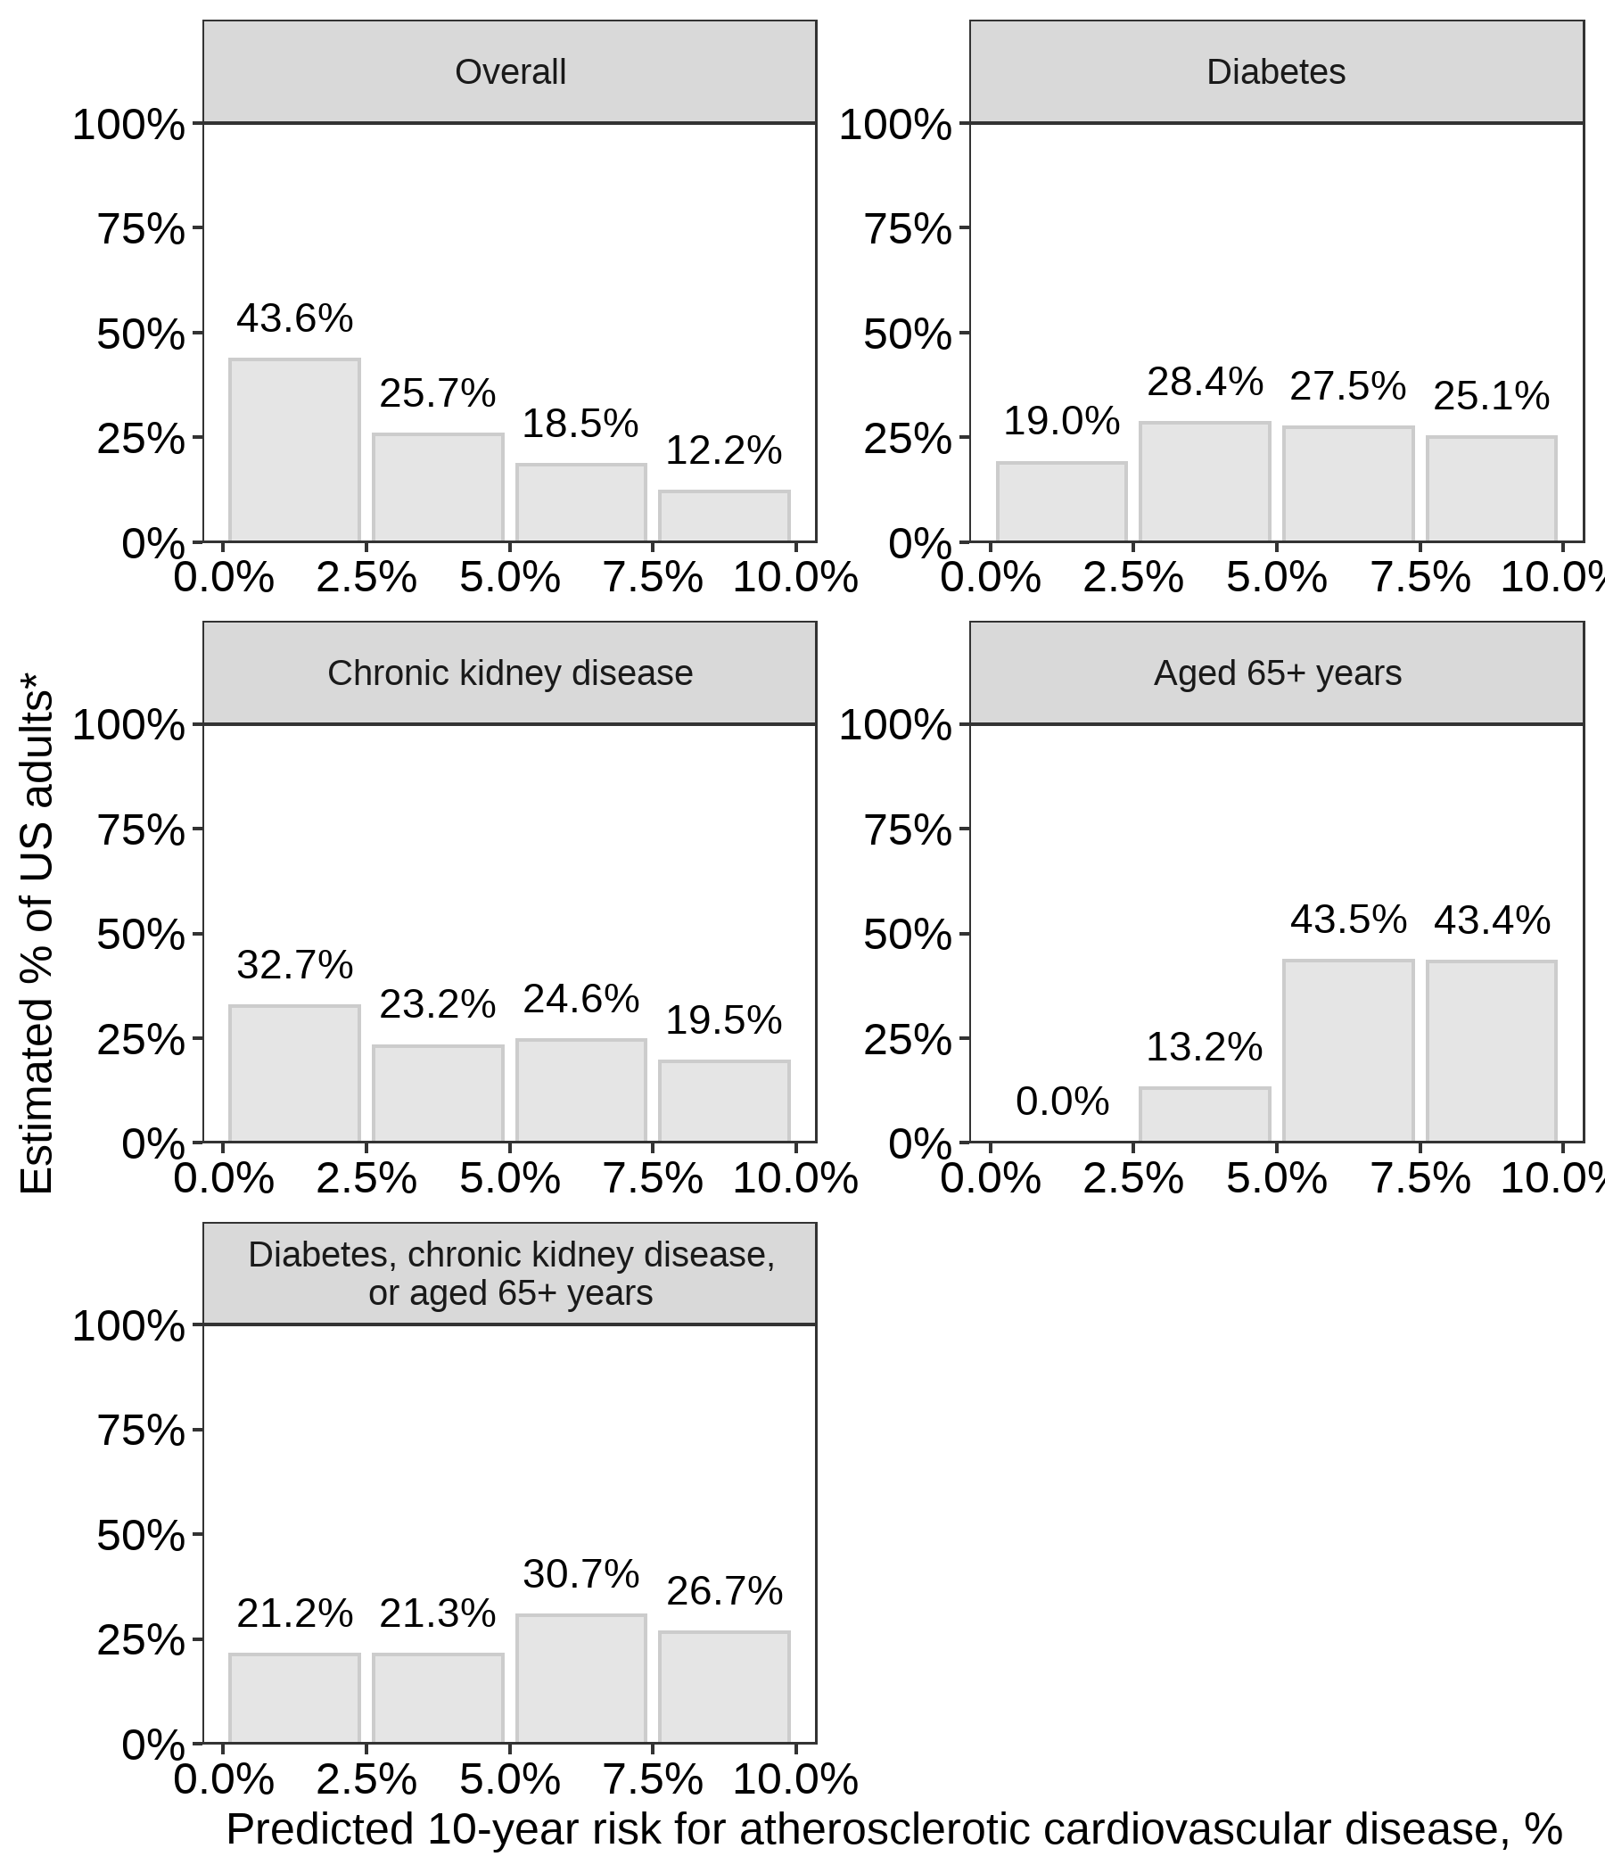

* The distributions are restricted to US adults without clinical cardiovascular disease and 10-year predicted atherosclerotic cardiovascular disease risk < 10%.

Figure 2: Estimated probability of high atherosclerotic cardiovascular disease risk for US adults with diabetes, with chronic kidney disease, and without diabetes or chronic kidney disease.

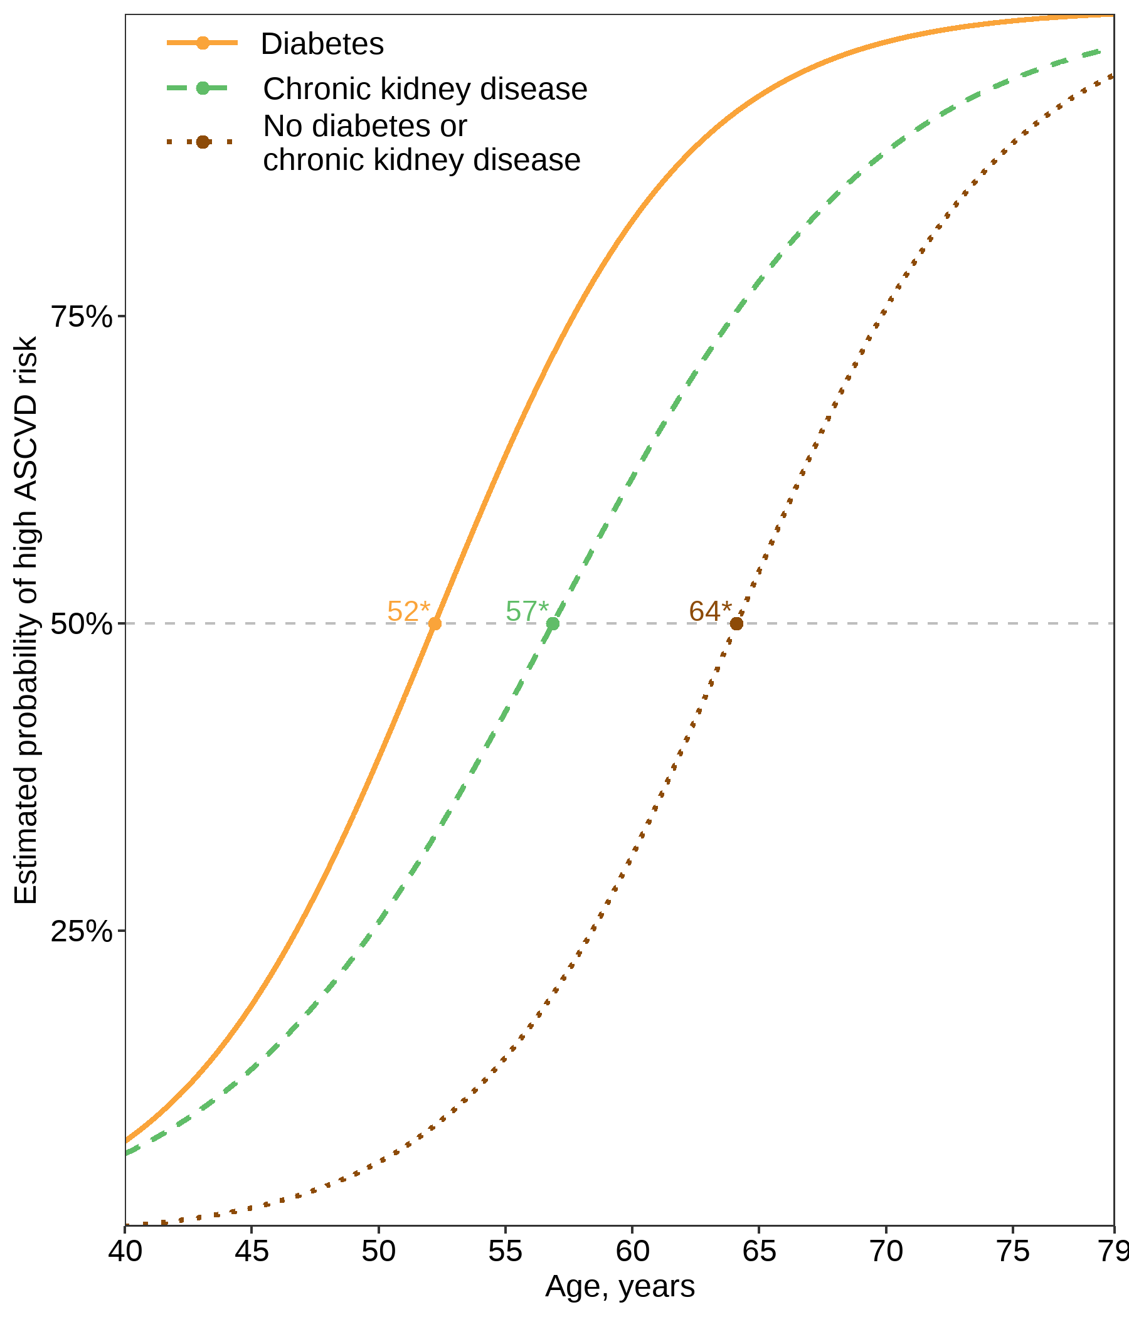

* Age at which 50% of the subgroup is estimated to have high atherosclerotic cardiovascular disease risk, defined as a predicted 10-year atherosclerotic cardiovascular disease risk ≥ 10% or clinical cardiovascular disease.

**SUPPLEMENT**

Table S1: Characteristics of US adults with stage 1 hypertension, overall and for subgroups defined by diabetes, chronic kidney disease, and ≥ 65 years of age.

|  | | **Sub-groups** | | | |
| --- | --- | --- | --- | --- | --- |
| **Characteristic\*** | **Overall  N = 1,271** | **Diabetes  N = 204†** | **CKD  N = 174‡** | **Age 65+ years  N = 236** | **Diabetes, CKD, or age 65+ years  N = 460** |
| Age, years | 54.0 (0.4) | 56.8 (1.2) | 57.7 (1.1) | 69.7 (0.4) | 61.5 (0.8) |
| Male | 52.3 | 58.5 | 49.3 | 51.5 | 51.9 |
| Race / ethnicity | | | | | |
| Non-Hispanic White | 66.3 | 60.0 | 61.6 | 73.8 | 65.3 |
| Non-Hispanic Black | 9.8 | 11.4 | 11.0 | 7.4 | 10.1 |
| Hispanic | 14.2 | 19.9 | 18.1 | 10.3 | 15.2 |
| Non-Hispanic Asian | 6.0 | 7.6 | 6.2 | 4.2 | 5.9 |
| Other Race/ethnicity - Including Multi-Racial | 3.7 | 1.2 | 3.0 | 4.4 | 3.4 |
| Current smoker | 19.3 | 18.8 | 20.5 | 10.7 | 16.2 |
| Total cholesterol, mg/dl | 205.0 (2.4) | 188.8 (4.6) | 196.5 (4.3) | 195.4 (3.5) | 195.7 (2.8) |
| HDL-cholesterol, mg/dl | 54.0 (0.7) | 47.1 (1.5) | 53.6 (2.0) | 57.9 (1.4) | 53.8 (1.0) |
| Heart rate, beats per minute | 72.8 (0.4) | 75.4 (1.2) | 73.4 (1.2) | 70.4 (0.8) | 72.8 (0.6) |
| Systolic blood pressure, mm Hg | 129.6 (0.3) | 131.1 (0.7) | 131.4 (0.6) | 132.5 (0.6) | 131.4 (0.4) |
| Diastolic blood pressure, mm Hg | 78.6 (0.4) | 76.7 (1.0) | 75.8 (0.8) | 72.2 (1.0) | 75.2 (0.7) |
| Antihypertensive medication use | 0.0 | 0.0 | 0.0 | 0.0 | 0.0 |
| Diabetes | 12.3 | 100.0 | 30.1 | 21.0 | 41.7 |
| CKD | 10.5 | 25.6 | 100.0 | 19.8 | 35.5 |
| Aged 65+ years | 15.7 | 26.9 | 29.9 | 100.0 | 53.4 |
| Diabetes, chronic kidney disease, or age 65+ years | 29.5 | 100.0 | 100.0 | 100.0 | 100.0 |
| Clinical CVD§ | 5.8 | 15.2 | 11.1 | 13.2 | 11.2 |
| *Table values are mean (standard error) or proportion. | | | | | |
| †Diabetes was defined by fasting serum glucose ≥ 126 mg/dL, non-fasting glucose ≥ 200 mg/dL, glycated hemoglobin (HbA1c) ≥ 6.5%, or self-reported use of insulin or oral glucose lowering medication. | | | | | |
| ‡Chronic kidney disease is defined by an albumin-to-creatinine ratio ≥ 30 mg/g or an estimated glomerular filtration rate < 60 ml/min/1.73m² | | | | | |
| §Clinical cardiovascular disease was defined by self-report of previous heart failure, coronary heart disease, stroke, or myocardial infarction | | | | | |
| CKD = chronic kidney disease; CVD = cardiovascular disease; HDL = high density lipoprotein | | | | | |
| Stage 1 hypertension was defined as having untreated systolic blood pressure between 130 and 139 mm Hg with diastolic blood pressure < 90 mm Hg or diastolic blood pressure between 80 and 89 mm Hg with systolic blood pressure < 90 mm Hg | | | | | |

Figure S1: Flowchart showing the application of the inclusion criteria to National Health and Nutrition Examination Survey 2013-2018 participants

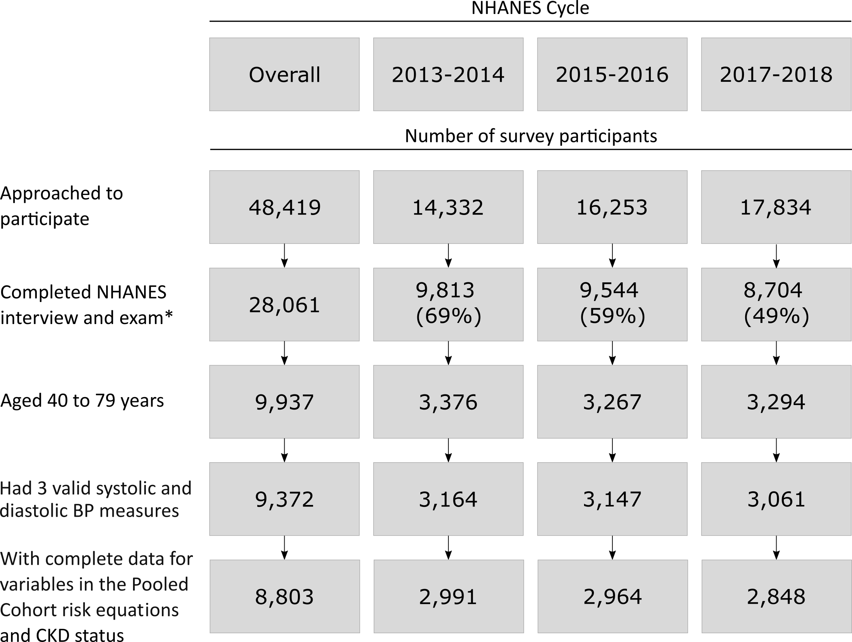

* The completed National Health and Nutrition Examination Survey interview and exam cells include number with the response rate in parentheses. BP = blood pressure; CKD = chronic kidney disease; NHANES = National Health and Nutrition Examination Survey.

Figure S2: Distribution of 10-year predicted risk for atherosclerotic cardiovascular disease among US adults with stage 1 hypertension and predicted risk < 10%, overall and for subgroups defined by diabetes, chronic kidney disease, and ≥ 65 years of age.

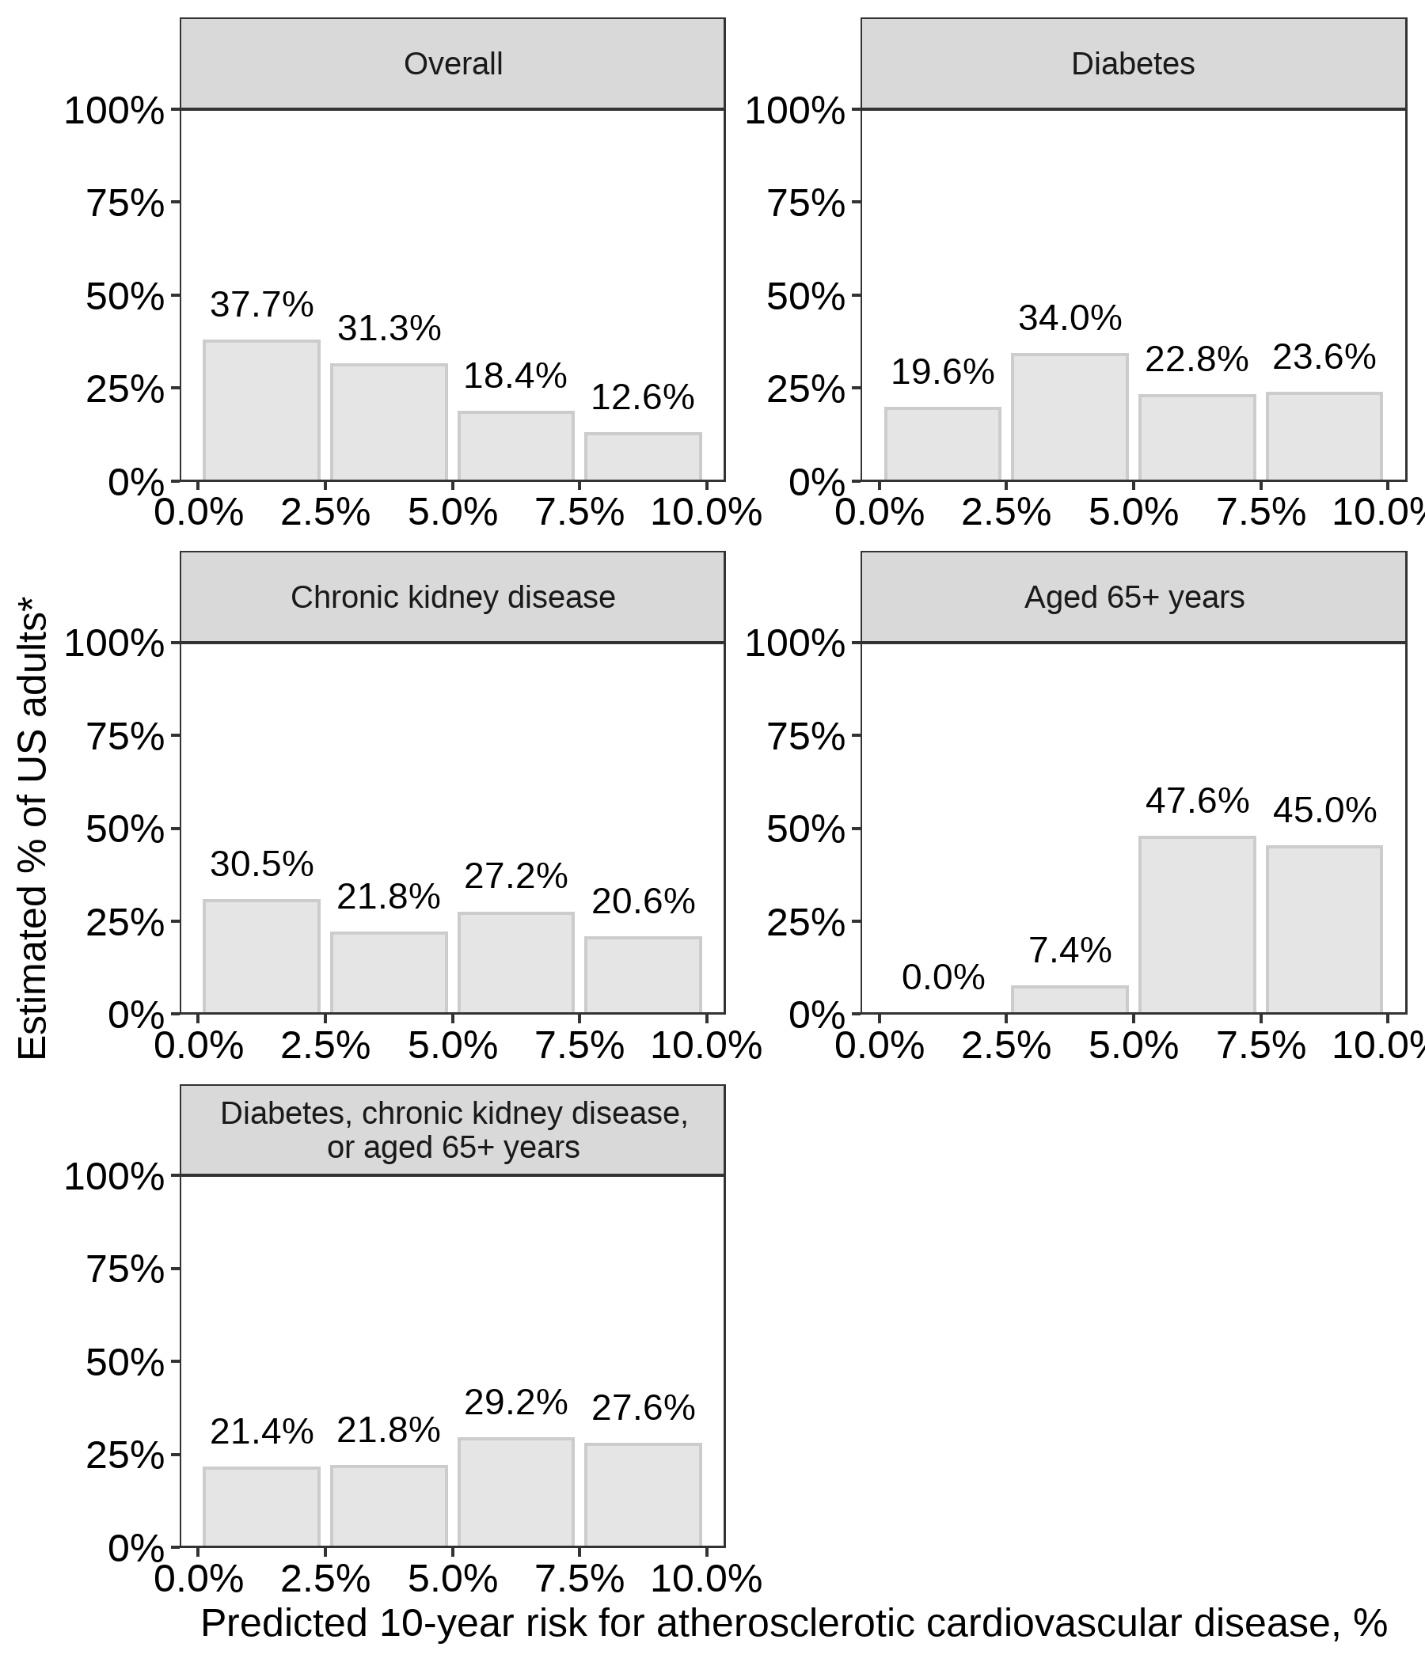

* The distributions are restricted to US adults without clinical cardiovascular disease and 10-year predicted atherosclerotic cardiovascular disease risk < 10%.

Figure S3: Estimated Probability of high atherosclerotic cardiovascular disease risk for US adults with stage 1 hypertension and with diabetes, with chronic kidney disease, and without diabetes or chronic kidney disease.

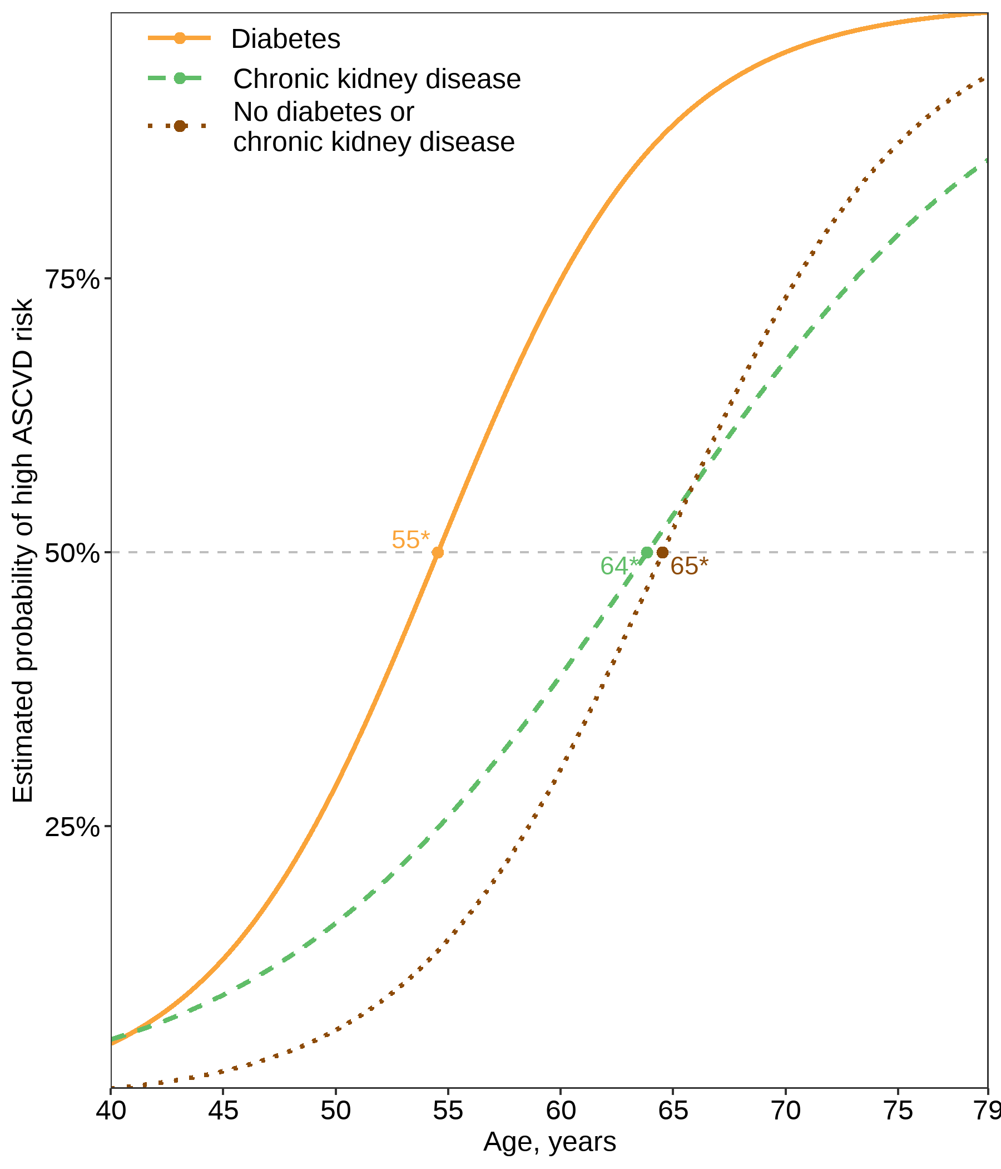

* Age at which 50% of the subgroup is estimated to have high atherosclerotic cardiovascular disease risk, defined as a predicted 10-year atherosclerotic cardiovascular disease risk ≥ 10% or clinical cardiovascular disease.

**Acknowledgments:** None.

# REFERENCES

1 Whelton PK, Carey RM, Aronow WS, Casey DE, Collins KJ, Himmelfarb CD *et al.* 2017 ACC/AHA/AAPA/ABC/ACPM/AGS/APhA/ASH/ASPC/NMA/PCNA guideline for the prevention, detection, evaluation, and management of high blood pressure in adults: A report of the American college of cardiology/American heart association task force on clinical practice guidelines. *Journal of the American College of Cardiology* 2018; 71:e127–e248.

2 Goff DC, Lloyd-Jones DM, Bennett G, Coady S, D’agostino RB, Gibbons R *et al.* 2013 ACC/AHA guideline on the assessment of cardiovascular risk: A report of the American college of cardiology/American heart association task force on practice guidelines. *Journal of the American College of Cardiology* 2014; 63:2935–2959.

3 Shillinglaw B, Viera AJ, Edwards T, Simpson R, Sheridan SL. Use of global coronary heart disease risk assessment in practice: A cross-sectional survey of a sample of us physicians. *BMC health services research* 2012; 12:20.

4 NHANES. National health and nutrition examination survey homepage, available at <https://www.cdc.gov/nchs/nhanes/index.htm>. Accessed on 09/07/2020.

5 NHANES. Tutorials - module 3 - weighting, available at <https://wwwn.cdc.gov/nchs/nhanes/tutorials/module3.aspx>. Accessed on 09/07/2020.

6 Levey AS, Stevens LA, Schmid CH, Zhang Y, Castro III AF, Feldman HI *et al.* A new equation to estimate glomerular filtration rate. *Annals of internal medicine* 2009; 150:604–612.

7 Pattaro C. *Nephro: Utilities for nephrology*.; 2017. <https://CRAN.R-project.org/package=nephro>

8 Lloyd-Jones DM, Braun LT, Ndumele CE, Smith SC, Sperling LS, Virani SS *et al.* Use of risk assessment tools to guide decision-making in the primary prevention of atherosclerotic cardiovascular disease: A special report from the american heart association and american college of cardiology. *Journal of the American College of Cardiology* 2019; 73:3153–3167.

9 R Core Team. *R: A language and environment for statistical computing*. Vienna, Austria: R Foundation for Statistical Computing; 2020. <https://www.R-project.org/>

10 Landau WM. The drake R package: A pipeline toolkit for reproducibility and high-performance computing. *Journal of Open Source Software* 2018; 3.<https://doi.org/10.21105/joss.00550>

11 Wickham H, Averick M, Bryan J, Chang W, McGowan LD, François R *et al.* Welcome to the tidyverse. *Journal of Open Source Software* 2019; 4:1686.

12 Jaeger B. *table.glue: Make and apply customized rounding specifications for tables*.; 2020. doi:[10.5281/zenodo.4107159](https://doi.org/10.5281/zenodo.4107159)

13 Colantonio LD, Booth JN, Bress AP, Whelton PK, Shimbo D, Levitan EB *et al.* 2017 American college of cardiology/American heart association blood pressure treatment guideline recommendations and cardiovascular risk. *Journal of the American College of Cardiology* 2018; 72:1187–1197.

14 Jaeger BC, Anstey DE, Bress AP, Booth III JN, Butler M, Clark III D *et al.* Cardiovascular disease and mortality in adults aged ≥60 years according to recommendations by the American college of cardiology/American heart association and American college of physicians/American academy of family physicians. *Hypertension* 2019; 73:327–334.

15 Herrett E, Gadd S, Jackson R, Bhaskaran K, Williamson E, Staa T van *et al.* Eligibility and subsequent burden of cardiovascular disease of four strategies for blood pressure-lowering treatment: A retrospective cohort study. *The Lancet* 2019; 394:663–671.

16 Schrier RW, Estacio RO, Esler A, Mehler P. Effects of aggressive blood pressure control in normotensive type 2 diabetic patients on albuminuria, retinopathy and strokes. *Kidney international* 2002; 61:1086–1097.

17 Cheung AK, Rahman M, Reboussin DM, Craven TE, Greene T, Kimmel PL *et al.* Effects of intensive blood pressure control in chronic kidney disease. *Journal of the American Society of Nephrology* 2017; 28:2812–2823.

18 SPRINT Research Group. A randomized trial of intensive versus standard blood-pressure control. *New England Journal of Medicine* 2015; 373:2103–2116.

19 Ettehad D, Emdin CA, Kiran A, Anderson SG, Callender T, Emberson J *et al.* Blood pressure lowering for prevention of cardiovascular disease and death: A systematic review and meta-analysis. *The Lancet* 2016; 387:957–967.

20 Bundy JD, Li C, Stuchlik P, Bu X, Kelly TN, Mills KT *et al.* Systolic blood pressure reduction and risk of cardiovascular disease and mortality: A systematic review and network meta-analysis. *JAMA cardiology* 2017; 2:775–781.

21 Reboussin DM, Allen NB, Griswold ME, Guallar E, Hong Y, Lackland DT *et al.* Systematic review for the 2017 ACC/AHA/AAPA/ABC/ACPM/AGS/APhA/ASH/ASPC/NMA/PCNA guideline for the prevention, detection, evaluation, and management of high blood pressure in adults: A report of the American college of cardiology/American heart association task force on clinical practice guidelines. *Journal of the American College of Cardiology* 2018; 71:2176–2198.

22 Coresh J, Astor B, Sarnak MJ. Evidence for increased cardiovascular disease risk in patients with chronic kidney disease. *Current opinion in nephrology and hypertension* 2004; 13:73–81.

23 Chronic Kidney Disease Prognosis Consortium and others. Association of estimated glomerular filtration rate and albuminuria with all-cause and cardiovascular mortality in general population cohorts: A collaborative meta-analysis. *The Lancet* 2010; 375:2073–2081.

24 Grundy SM, Benjamin IJ, Burke GL, Chait A, Eckel RH, Howard BV *et al.* Diabetes and cardiovascular disease: A statement for healthcare professionals from the American heart association. *Circulation* 1999; 100:1134–1146.

25 Lakatta EG. Age-associated cardiovascular changes in health: Impact on cardiovascular disease in older persons. *Heart failure reviews* 2002; 7:29–49.

26 Lloyd-Jones DM, Leip EP, Larson MG, d’Agostino RB, Beiser A, Wilson P *et al.* Prediction of lifetime risk for cardiovascular disease by risk factor burden at 50 years of age. *Circulation* 2006; 113:791–798.

27 Hippisley-Cox J, Coupland C, Robson J, Brindle P. Derivation, validation, and evaluation of a new QRISK model to estimate lifetime risk of cardiovascular disease: Cohort study using QResearch database. *BMJ* 2010; 341.

28 Allen NB, Siddique J, Wilkins JT, Shay C, Lewis CE, Goff DC *et al.* Blood pressure trajectories in early adulthood and subclinical atherosclerosis in middle age. *Jama* 2014; 311:490–497.